**CDS assignment 1**

**UID : 2309028**

**AIM :**

**Benchmark**  **different flavours of python like cpython, pypy, ironpython, tec.**

**Introduction:**

In this report, we present a comparison of three different Python flavours, namely CPython, PyPy, and Iron Python, for converting the content of a .txt file into uppercase and sorting a csv file based on a column in the csv file.

**Test 1 :**

Dataset is a .txt file ‘input.txt’ with a content of **5899 words** and converting the entire content to uppercase and saving it in a new .txt file named ‘output.txt’.

**Pypy implementation :**

Time elapsed - 0.0312 seconds



**Iron python implementation :**

Time elapsed - 1.123 seconds

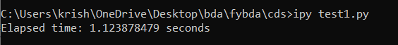

**Cpython implementation :**

Time elapsed - 0.0630

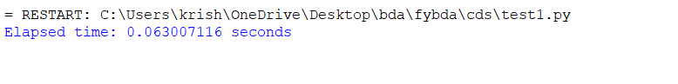

**CONCLUSION for Test 1 :**

PyPy was the fastest while Iron Python was the slowest.

**Test 2 :**

-Dataset used is a .csv file. The .csv file is sorted based on the ‘Value’ column using pypy, iron and ‘c’ python

-The csv file has **41716 rows and 10 columns.**

**PyPy implementation :**

Elapsed time - 2.9364 seconds

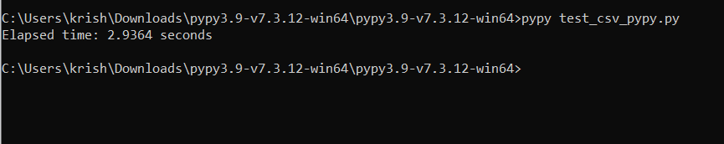

**Ironpython implementation :**

Elapsed time - 2.5129 seconds

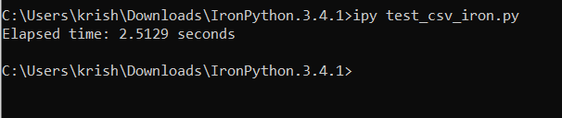

**Cpython implementaion :**

Elapsed time - o.3436 seconds

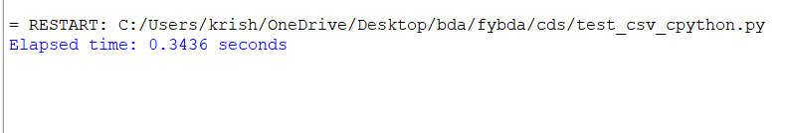

**CONCLUSION for Test 2 :**

Cpython was the fastest while PyPy python was the slowest

**RESULT :**

-While handling a small text file PyPy was the fastest.

-While handling a relatively much larger csv file Cpython was exponentially faster than both PyPy and IronPython, PyPy being the slowest.